

**BRAC Online Career Hub**

Application User Manual (Phase-04)

Document Version 1.0  
05 December 2021

**Disclaimer**

This guide has been validated and reviewed for accuracy. The instructions and descriptions it contains are accurate for Phase-04 of BRAC Online Career Hub application. However, succeeding versions and guides are subject to change without notice.

**Revision History**

|  |  |  |  |
| --- | --- | --- | --- |
| Revision No. | Created/Updated By | Release Date | Comments |
| 1.0 | A S M Lutful Kabir | 05 December 2021 | 1st Release |

Table of Contents

1 About this Guide 7

2 Purpose of this Guide 7

3 Typographical Conventions 7

4 Contact Information 8

5 Solution Background – BRAC Online Career Hub 8

6 Application Channel 9

7 BRAC Online Career Hub Application 9

7.1 Application Landing Page 10

7.2 Application Registration 12

8 Admin Module 14

8.1 Admin Dashboard 14

8.2 User Management 15

8.2.1 All Center 15

8.2.2 Create Center 17

8.3 Create New User (Counsellor) 18

8.4 Counselling 20

8.5 Role Management 21

8.5.1 Create New Role (Counsellor) 22

8.6 Portal Feedback 24

8.6.1 Add new question for Portal Feedback 26

8.6.2 Portal Feedback Response 27

8.7 Web Seminar 29

8.7.1 Create New Web Seminar 30

8.8 FAQ 31

8.8.1 Create New Question (FAQ) 32

9 Counsellor Module 33

9.1 Requested Participant 34

9.2 All Participant 35

9.3 Create New Counselling 36

9.4 Create Task for Participant (counselling) 38

9.5 Already Scheduled Counselling 42

10 Participant Module 43

10.1 Application Registration (Participant) 43

10.1.1 Participant Registration Form 44

10.1.2 Participant Login 45

10.1.3 Participant Dashboard 46

10.2 Career Counselling list 47

10.2.1 Task List (Counselling) 48

10.2.2 Request Counselling 49

10.2.3 Join A Counselling Session 51

10.3 Join Seminar 52

10.3.1 Seminar Page 53

10.4 Chat Bot 53

10.5 Portal Feedback (Participant) 54

List Of Tables

Table 1: Online Career Hub Landing Page 11

Table 2 Registration Page details Login 12

Table 3: Login page details 13

Table 4 All Center list column details 16

Table 5 All Center Page Details 16

Table 6 Create Center 17

Table 7 User Information form details 19

Table 8 Counselling List table details 20

Table 9 Create New Role Form Details 23

Table 10 All Role list page details 23

Table 11 All Feedback Column details 24

Table 12 All Feedback page details 25

Table 13 Create Question form details 26

Table 14 All Feedback Response Table Details 27

Table 15 All Feedback Response Page Details 28

Table 16 All Web Seminars Table Details 29

Table 17 Create New Seminar Form details 30

Table 18 Create Counselling Form 37

Table 19 Create New Task form (counselling) 41

Table 20 Applications Registration Form Details 45

Table 21 Counselling List Page details 47

Table 22 Request Counselling form details 49

**List of Figures**

Figure 1: Application Landing Page 10

Figure 2: Popular Course in Landing Page 11

Figure 3: Dynamic enrollment counts of participants & trainers 11

Figure 4: Registration Page 12

Figure 5 Login page 13

Figure 6: Admin Dashboard 14

Figure 7 All Cente List Page 15

Figure 8: Create New Center form 17

Figure 9 User management page 18

Figure 10 Create New User Form 18

Figure 11 Counselling Management Page 20

Figure 12 Role Management Page 21

Figure 13 Create New Role (Counsellor) 22

Figure 14 Portal Feedback page 24

Figure 15 Create Question Form (Portal Feedback) 26

Figure 16 All Portal Feedback Response Page 27

Figure 17 Web Seminar management page 29

Figure 18 Create New Seminar form 30

Figure 19 FAQ Page 31

Figure 20 Create New FAQ Question Form 32

Figure 21 Counsellor Module 33

Figure 22 Requested Participant Page 34

Figure 23 All Participant List 35

Figure 24 Create Counselling Form 36

Figure 25 Counselling Session 37

Figure 26 Participant Profile page 38

Figure 27 Counselling Session Page details 39

Figure 28 Create New Task Form 40

Figure 29 Create New Task (Counselling) 40

Figure 30 Already Scheduled page 42

Figure 31 Application landing page 43

Figure 32 Participant Registration Form 44

Figure 33 Login Form 45

Figure 34 Participant Dashboard 46

Figure 35 External Employer Dashboard 46

Figure 36 Counseling List 47

Figure 37 Task List Page 48

Figure 38 Request Counselling Form 49

Figure 39 Counselling Lists Table 50

Figure 40 Confirmation message for Request counselling session 50

Figure 41 Confirmation Message 50

Figure 42 join a session 51

Figure 43 Participant Dashboard (Seminar) 52

Figure 44 Seminar Page 53

Figure 45 Chat bot 53

Figure 46 My Portal Feedback page 54

# About this Guide

This document will deliberately guide you to use every possible option/feature of Online Career Hub application’s 4th phase in details.

# Purpose of this Guide

This document describes functional and application level features of BRAC Online Career Hub application. However, through this guide user will get conversant with application’s 4th phase usage/working procedures.

The users/stakeholders of this application should get a rigid overview on the application’s 4th phase through this guide.

*User*: The primary users for this application would be BRAC employees, trainers and other allotted members/users who would be categorized in the system as:

* Admin;
* Participants;
* Counsellor

# Typographical Conventions

|  |  |
| --- | --- |
| Type Face | Meaning |
| **Bold** | Used to indicate buttons on the screen. |
| *Italic* | Used as special instructions/actions/notes and reference to other sections. |

# Contact Information

|  |  |  |  |
| --- | --- | --- | --- |
| Name | Designation | Email | Phone |
| Nipun Ferdous | Junior Business  Analyst | nipun.ferdous@shebatech.com.bd | 01847418964 |

# Solution Background – BRAC Online Career Hub

BRAC has been working on creating a workforce through their skills development program (SDP) since 2015. It has a mission of empowering youths through skills development and decent employment so that a competent workforce can lead our nation forward. The program’s outcomes are aligned to the SDG (sustainable development goal) which would be ensuring skills for youth and adults for decent employment and entrepreneurship and SDG 8 (promoting sustained, inclusive and sustainable economic growth, full and productive employment and decent work for all).

COVID-19 pandemic has restricted the scopes of physical training. Given the government’s embargoes, the educational institutions have been remained closed since 17 March, 2020. On the other hand, nearly 25 million of the global population are anticipated to lose their jobs due to the COVID-19 crisis, according to the recent report of the International Labour Organization (ILO). A staggering increase in the unemployment rate in Bangladesh is also evident. The reasons for this sharp increase in youth unemployment are, restrictions in the new recruitment, sudden job loss and so on. Given these circumstances, skills training through digital platforms is imperative. Since the pandemic caused a massive impact of deduction from the ongoing workforce and their opportunities, the job seekers will need to be competitive in terms of increasing skill sets that would fit most appropriately with the existing market.

Phase-04 of Online Career Hub Solution will enable its users with following key capabilities:

**As an Admin**

* Create counsellor Role
* Create counselor profile;
* Define center for counselor ;
* Create new questions for portal feedback;
* Create FAQ;
* View Portal Feedback Response;
* Create Web seminar;

**As an Counselor**

* Create counselling Session
* Create Requested counselling for Participant
* Create Task For Participant

**As a Participant**

* Request for counselling session;
* Portal Feedback;
* View Web seminar
* Chat bot ;

# Application Channel

The application will be used by intended users on their PC / Laptops via web.

# BRAC Online Career Hub Application

Through this document user will get a complete walk through over the application’s Fourth phase. From Below, each and every module and its underside features, relevant actions and usage criteria are depicted.

## Application Landing Page

The Landing page will provide an overall glimpse of the entire solution. Users from all roles will be able to login using their unique username and password as well as new user will be able to register to the system from this page.

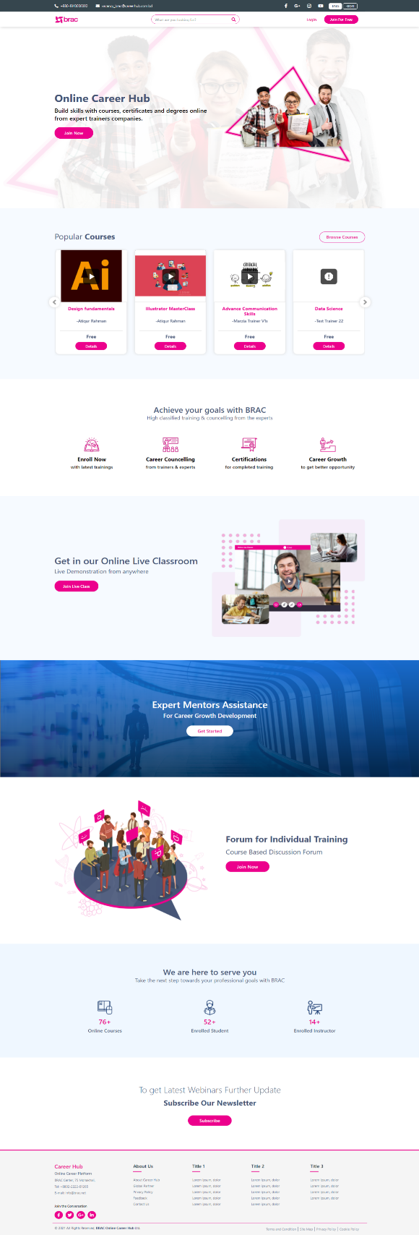

Figure 1: Application Landing Page

* 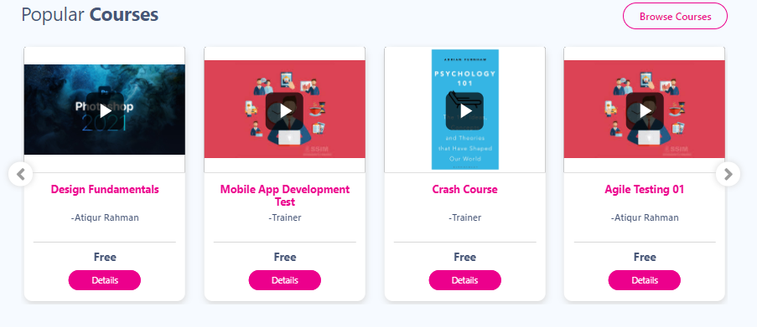The section Popular Courses will showcase the courses based on participants enrollment count.

Figure 2: Popular Course in Landing Page

* Users will be able to view online courses, enrolled instructors and participants dynamically from below section of the landing page.

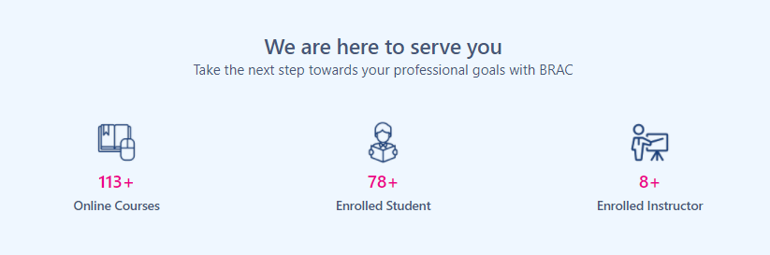

Figure 3: Dynamic enrollment counts of participants & trainers

|  |  |
| --- | --- |
| **Field**  **Name/Icon/Button** | **Description** |
|  | Click to go to the Login Page. |
|  | Clicking on **join for free** will show two drop down and clicking on any of drop down will redirect to application registration page. |
|  | Multilingual Toggle Button to interchange application interface language between Bangla and English. |

Table 1: Online Career Hub Landing Page

## Application Registration

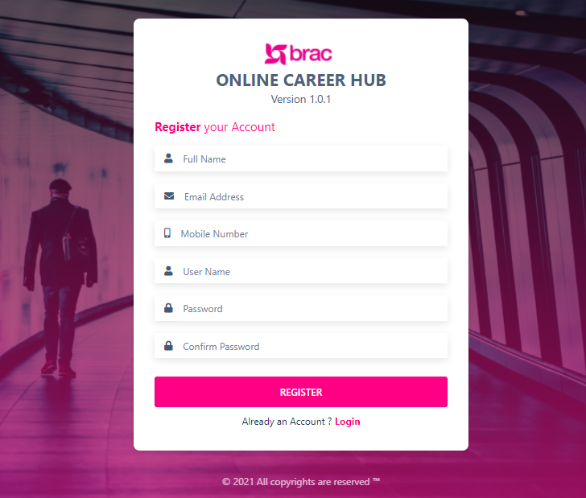

Figure 4: Registration Page

* Through this page user will be able to sign up for Online Career Hub application.

Table 2 Registration Page details Login

|  |  |
| --- | --- |
| **Field Name/Icon/Button** | **Description** |
| Full Name | Enter user full name |
| Email Address | Enter user email address |
| Mobile Number | Enter user mobile number |
| User Name | Enter user name |
| Password | Enter user password |
| Confirm Password | Re-enter / Confirm Password |
|  | After filling up all the fields above, click to register |
|  | Login for users already having an account |

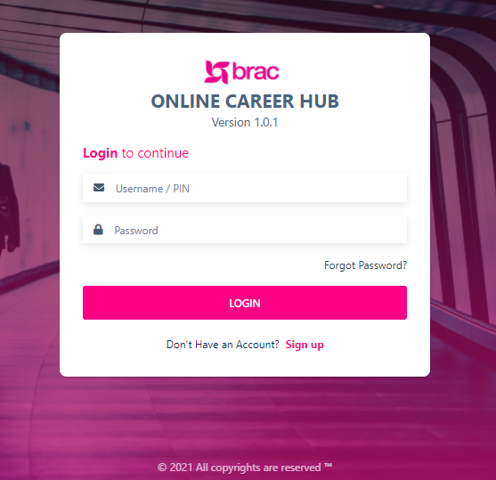

Figure 5 Login page

* Entering username/pin, password and hitting enter will let the user login to the system.

|  |  |
| --- | --- |
| **Field Name/Icon/Button** | **Description** |
| Username/PIN | Enter username/pin |
| Password | Enter Password |
|  | Hit login to enter the application |
|  | Click to sign up |

Table 3: Login page details

# Admin Module

In 4th phase of Online Career Hub, All Center, Counselling, Counsellor Role creation, Web Seminar, Portal Feedback, Portal Feedback Response Emoji Rating, has been added to the Admin Module.

## Admin Dashboard

**Click to Access User Management Sub-Menus**

**Click to Access Role Management Sub-Menus**

Figure 6: Admin Dashboard

## User Management

**Click to Create New Center**

**Click to Access All Center**

**Click to Access Portal Feedback**

**Click to Access Portal Feedback Response**

Figure 7 All Cente List Page

### All Center

* Click *User Management* to access the sub-menus
* Clicking on *All Center* will show Center List page by default
* This page consists following columns: Center Name, Division, District, Upazila, Counsellor, Status, Action;

|  |  |
| --- | --- |
| **Columns /Field Name/Icon/Button** | **Description** |
| ***Center Name*** | Name of the relevant center |
| ***Division*** | Name of the division of the center |
| ***District*** | Name of the District of the center |
| ***Upazila*** | Name of the Upazila |
| ***Counsellor*** | Name of the counsellor of the relevant center |
| ***Status*** | Active or Inactive status of the center |
| ***Action*** | Click to center details |

* Here are the following column details of All Center lists:

Table 4 All Center list column details

Table 5 All Center Page Details

|  |  |
| --- | --- |
| **Field Name/Icon/Button** | **Description** |
|  | Enables admin to search for any keyword; |
|  | Click to Download excel report. |
|  | Click to view the desired column in the table. |
|  | User can go back and forth of pages by clicking on the buttons. |
|  | Click to view rows per page and Jump to desired page. |
|  | Click to open create new Center; |
|  | Click to edit a center details; |

### Create Center

**Click to close the form**

**Click to Create Center**

Figure 8: Create New Center form

* Admin will Enter relevant information in the form for creating a new center;
* Admin can assign a specific Counsellor to a specific Center.

Table 6 Create Center

|  |  |
| --- | --- |
| **Columns /Field Name/Icon/Button** | **Description** |
| ***Center Name*** | Enter Name of the relevant center |
| ***Division*** | Select the Name of the division of the center |
| ***District*** | Select the Name of the District of the center |
| ***Upazila*** | Select the Name of the Upazila |
| ***Counsellor*** | Select the Name of the counsellor of the relevant center |
| ***Status*** | Set Active or Inactive status of the center |
|  | Clicking on the button will enable admin to create new company |
|  | Clicking on the button will close the form. |

## Create New User (Counsellor)

**Click to Create New User**

Figure 9 User management page

* 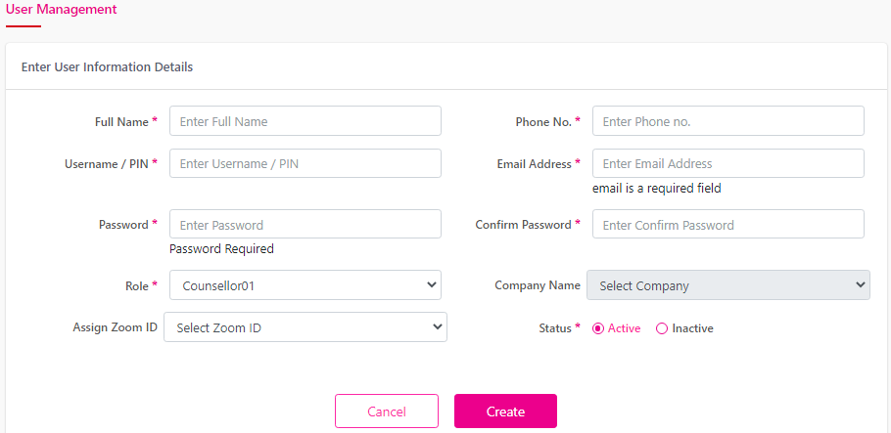Clicking on the Create New button from the user management page admin will redirect to user information details form

**Click to Create New User**

Figure 10 Create New User Form

**Click to Close the Form**

* Here user will enter relevant information for new user creation.
* By entering relevant information in the field admin will be able to create new user.

Table 7 User Information form details

|  |  |
| --- | --- |
| **Field Name/Icon/Button** | **Description** |
| ***Full Name*** | *Enter Full name of the employee* |
| ***Username/PIN*** | *Enter Pin or Username* |
| ***Phone No*** | *Enter Phone No.* |
| ***Email Address*** | *Enter Email address of the employer* |
| ***Password*** | *Enter password for user* |
| ***Confirm Password*** | *Confirm the password of the user* |
| ***Role*** | *Select Role type Counsellor from the drop down* |
| ***Status*** | *Set the active / Inactive from status* |

## Counselling

* 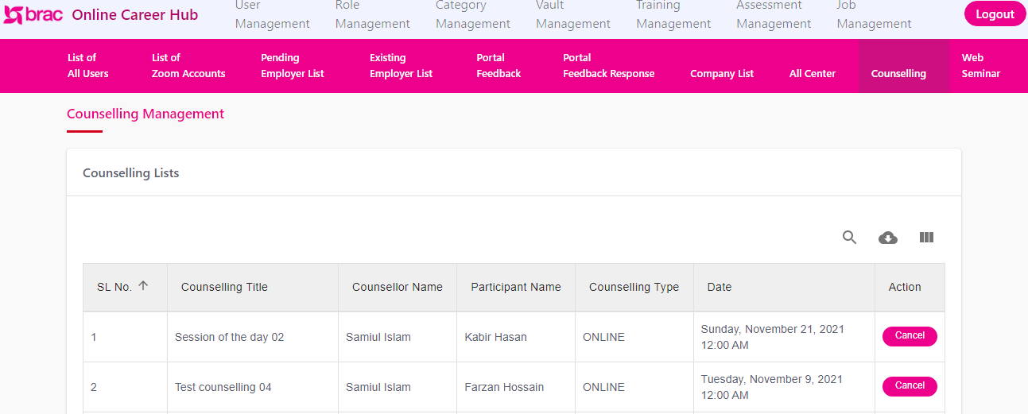Clicking on the counselling sub-menu will redirect to Counselling Management Page.

**Click to Cancel**

Figure 11 Counselling Management Page

**Click to Access**

* Here admin will find the Counselling list.
* Admin will find Details related to counselling.

Table 8 Counselling List table details

|  |  |
| --- | --- |
| **Field Name/Icon/Button** | **Description** |
| ***Counselling Title*** | *Title of the Counselling.* |
| ***Counsellor Name*** | *Name of the Counsellor* |
| ***Participant Name*** | *Name of the Participant* |
| ***Counseling Type*** | *Type of the counselling* |
| ***Date*** | *Date of the Counselling* |
| ***Action*** | *Relevant action for the counselling* |
|  | *Clicking on the button will cancel the counselling* |

## Role Management

**Click to Access Role Management**

**Click to Edit Role**

Figure 12 Role Management Page

* 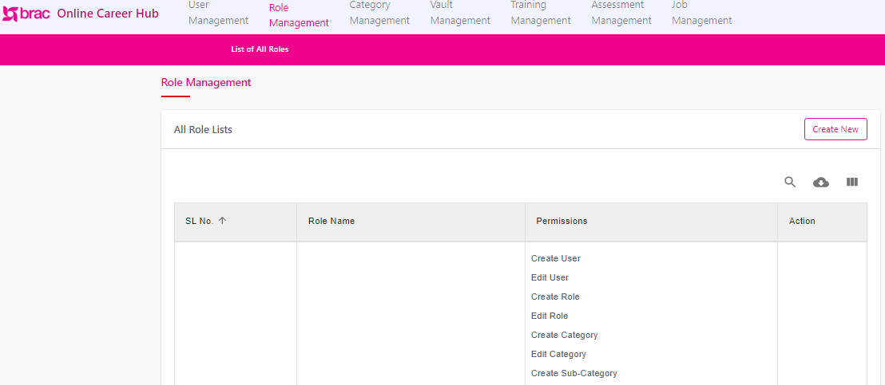Click *Role Management to* access All Role list Page

**Click to Create New Role**

* Here we will find this column
  + Role name
  + Permissions
  + Actions;

### Create New Role (Counsellor)

**Click to close form**

**Click to Create New Role**

Figure 13 Create New Role (Counsellor)

* Clicking on Create New button will redirect admin to Create New Role Page
* In this form Admin user will be able to create a role of Counsellor;

Table 9 Create New Role Form Details

|  |  |
| --- | --- |
| **Field Name/Icon/Button** | **Description** |
| ***Role Name*** | *Here enter the name of the Role* |
| ***Role Type*** | *Select Role Type Counsellor from the drop down* |
| ***Permissions*** | *Relevant permissions of the role.* |
|  | *Clicking on the button will enable admin to create a new role* |
|  | *Clicking on the button will close the form* |

Table 10 All Role list page details

|  |  |
| --- | --- |
| **Field Name/Icon/Button** | **Description** |
|  | Enables admin to search for any keyword; |
|  | Click to Download excel report. |
|  | Click to view the desired column in the table. |
|  | User can go back and forth of pages by clicking on the buttons. |
|  | Click to view rows per page and Jump to desired page. |
|  | Click to open create new Center; |
|  | Click to edit a center details; |

## Portal Feedback

* 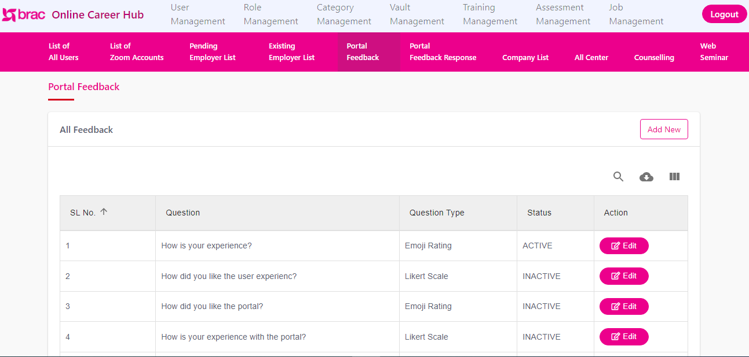Clicking on Feedback it will redirect to All Feedback sub menu

**Click to Edit Question**

**Click to Add new Question**

Figure 14 Portal Feedback page

* Here admin will be able to add new questions for Portal feedback
* Here admin will find following column:
* Question
* Question Type
* Status
* Action

Table 11 All Feedback Column details

|  |  |
| --- | --- |
| **Column/Field Name/Icon/Button** | **Description** |
| ***Question*** | The feedback relevant question |
| ***Question Type*** | Type of the question |
| ***Status*** | Active / Inactive status of the question |
| ***Actions*** | Edit or change the questions |
|  | Click to Edit the Question |

|  |  |
| --- | --- |
| **Field Name/Icon/Button** | **Description** |
|  | Enables admin to search for any keyword; |
|  | Click to Download excel report. |
|  | Click to view the desired column in the table. |
|  | User can go back and forth of pages by clicking on the buttons. |
|  | Click to view rows per page and Jump to desired page. |
|  | Click to open create new Center; |
|  | Click to edit a center details; |

Table 12 All Feedback page details

### Add new question for Portal Feedback

* 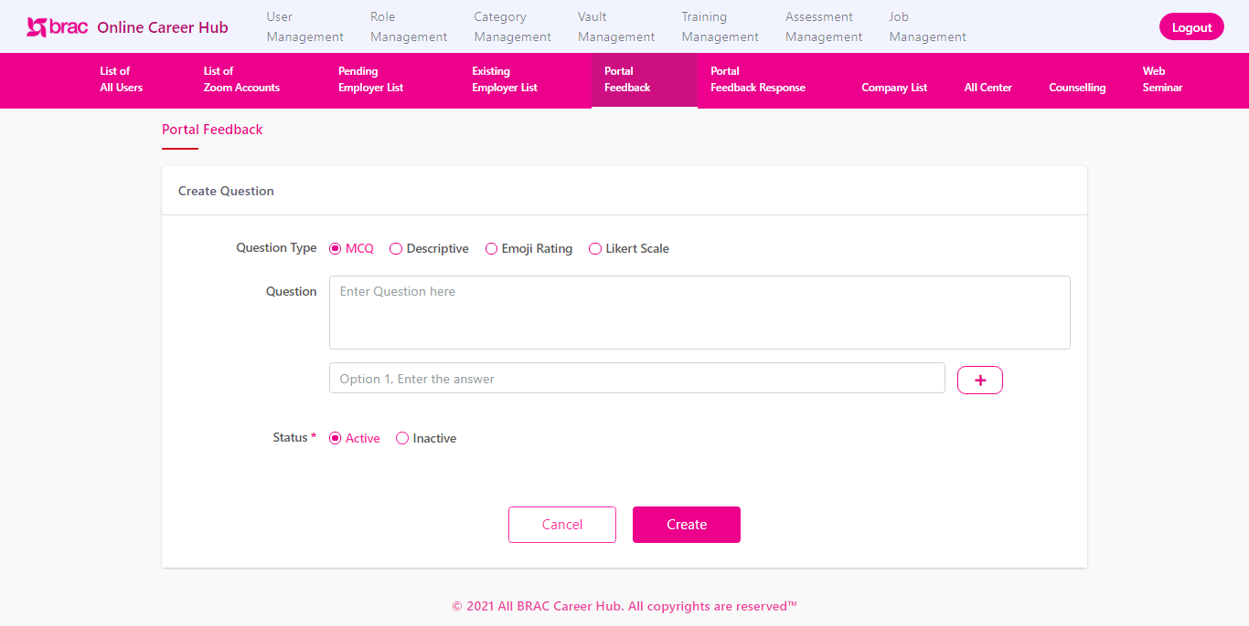Clicking on the Add New button will redirect to Create Question page.

**Click to create Question**

Figure 15 Create Question Form (Portal Feedback)

**Click to close Form**

* Here Admin will fill up the form with relevant information to create new question for Portal feedback

Table 13 Create Question form details

|  |  |
| --- | --- |
| **Field Name/Icon/Button** | **Description** |
| ***Question Type*** | Select type from multiple/descriptive/ Emoji Rating/ Liker Scale |
| ***Question*** | Enter relevant question. |
| ***Option*** | Add desired option |

### Portal Feedback Response

**Click to Access**

Figure 16 All Portal Feedback Response Page

* Clicking on Portal Feedback Response menu it will redirect admin to All Feedback Response page.
* Here admin will see following columns:
* Email
* Date
* Action

Table 14 All Feedback Response Table Details

|  |  |
| --- | --- |
| **Column/Field Name/Icon/Button** | **Description** |
| ***Email*** | Relevant Email Address |
| ***Date*** | Relevant Date for the feedback response |
| ***Action*** | Click to see the details of the feedback response |
| ***Details*** | By clicking on the button admin will be able to see the details of the response |

Table 15 All Feedback Response Page Details

|  |  |
| --- | --- |
| **Field Name/Icon/Button** | **Description** |
|  | Enables admin to search for any keyword; |
|  | Click to Download excel report. |
|  | Click to view the desired column in the table. |
|  | User can go back and forth of pages by clicking on the buttons. |
|  | Click to view rows per page and Jump to desired page. |
|  | Click to open create new Center; |
|  | Click to edit a center details; |

## Web Seminar

* 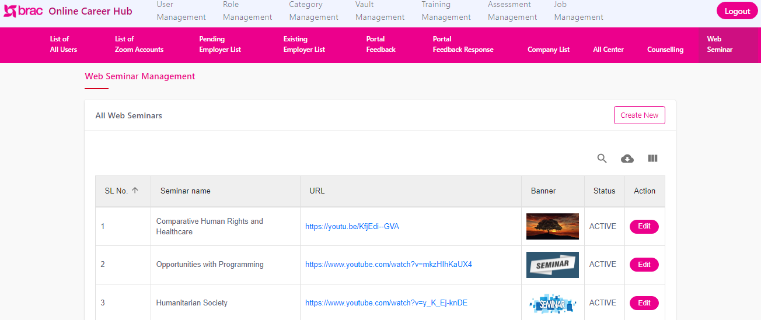Clicking on the Web seminar sub menu admin will redirect to All Web Seminar management page

**Click to Access**

**Click to Access**

**Click to Access**

Figure 17 Web Seminar management page

* Here user will find all the details related to Web Seminar.
* Here admin will see following columns:

Table 16 All Web Seminars Table Details

|  |  |
| --- | --- |
| **Column/Field Name/Icon/Button** | **Description** |
| ***Seminar Name*** | Name of the Seminar |
| ***URL*** | Relevant url of the Web seminar |
| ***Banner*** | Relevant Banner of the seminar |
| ***Status*** | Active or Inactive status of the Seminar |
| ***Action*** | Clicking on the button will redirect to Web seminar Management Page |

### Create New Web Seminar

Figure 18 Create New Seminar form

**Click to Create**

**Click to Cancel**

* Clicking on the Create new Button will redirect admin ton Create new web seminar for.
* By entering relevant information admin can create new Web seminar

Table 17 Create New Seminar Form details

|  |  |
| --- | --- |
| **Column/Field Name/Icon/Button** | **Description** |
| ***Seminar Name*** | Name of the Seminar |
| ***URL*** | Relevant url of the Web seminar |
| ***Seminar Date*** | Relevant Date of the Seminar |
| ***Seminar Time*** | Relevant Time of the seminar |
| ***Banner*** | Click to choose relevant Banner of the seminar |
| ***Status*** | Active or Inactive status of the Seminar |

## FAQ

Figure 19 FAQ Page

**Click to Delete**

**Click to Edit**

**Click to Access**

**Click to Access FAQ**

* Under the Category Management Menu user will find **FAQ** sub menu, clicking on FAQ user sub menu admin will redirect **FAQ Management Page**.
* From here user will find FAQ List.
* User can Create New FAQ question from here.
* Clicking on the **Edit b**utton user will be able to edit any FAQ question.
* From here user can delete any FAQ question by clicking on **Delete** button

### Create New Question (FAQ)

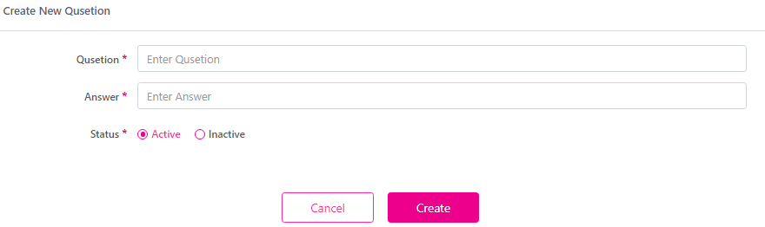

Figure 20 Create New FAQ Question Form

**Click to Close**

**Click to Create**

* From here user can add new question by using the **Question f**ield.
* Set active / inactive status of the question.

# Counsellor Module

* 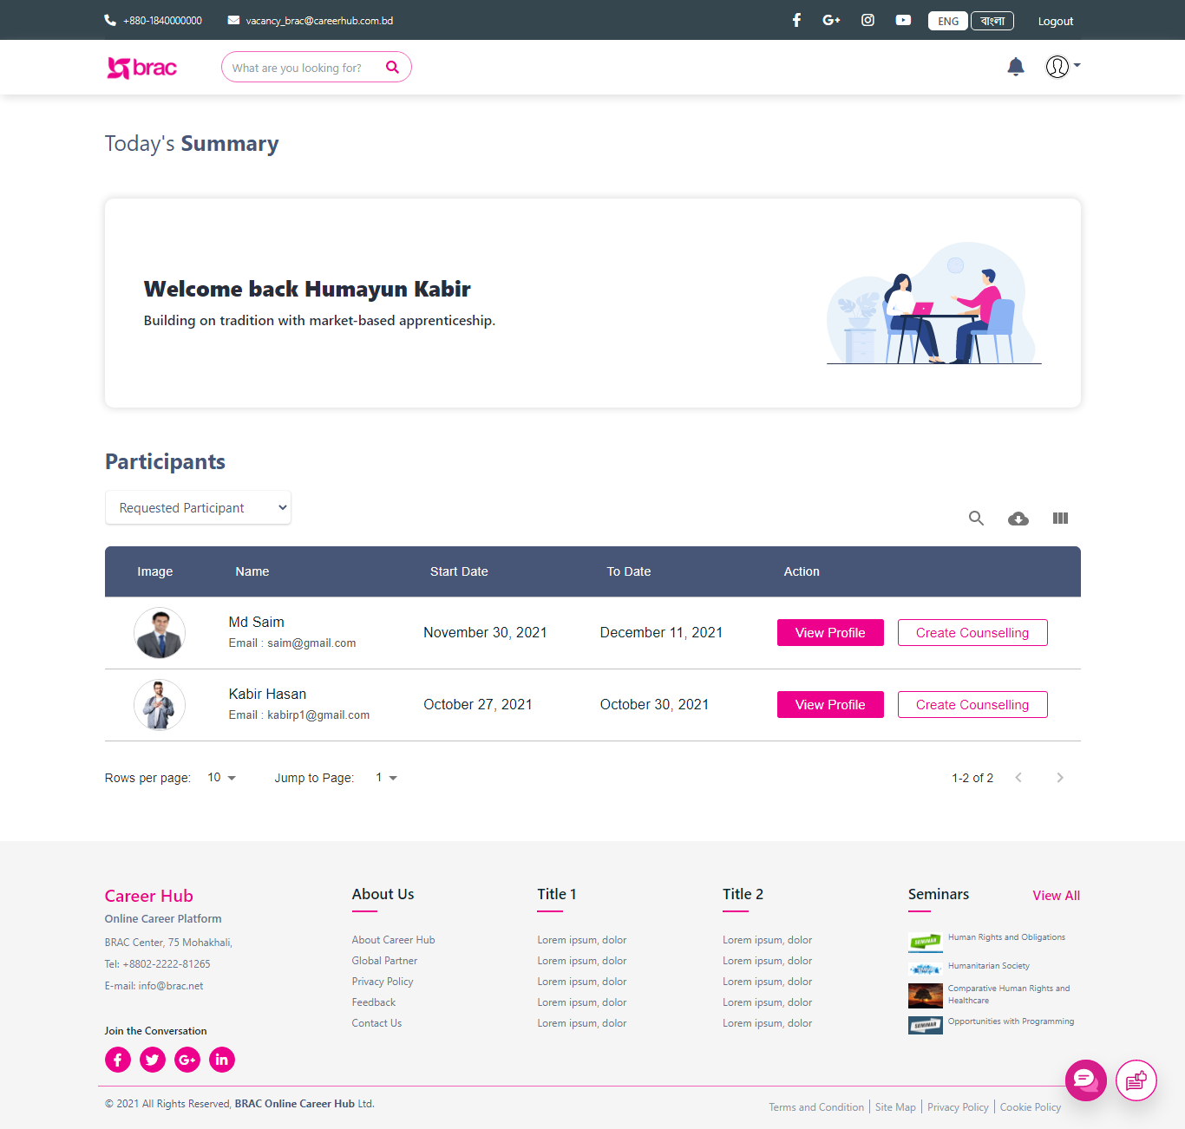With the given Credential by the admin, Counsellor User will log into the system.

Figure 21 Counsellor Module

* This is the Dashboard for counsellor.

## Requested Participant

* 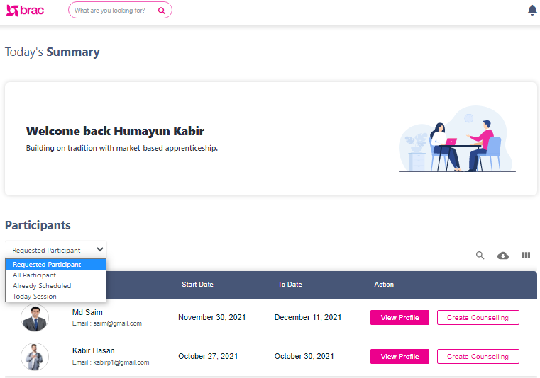Select Requested participant form the drop down to see the participant who requested for Counselling

**Click to Access**

**Click to Access**

**Click to Access**

Figure 22 Requested Participant Page

## All Participant

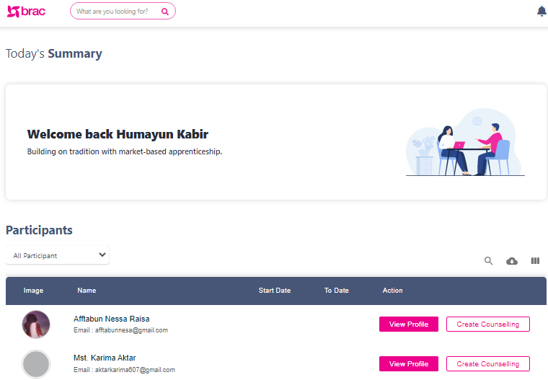

**Click to Access**

Figure 23 All Participant List

**Click to Access**

* Here user will find all the participant who he can counsel
* User can create counselling session for a specific participant form here.
* Clicking on Create Counselling, counsellor can create counselling for a participant.

## Create New Counselling

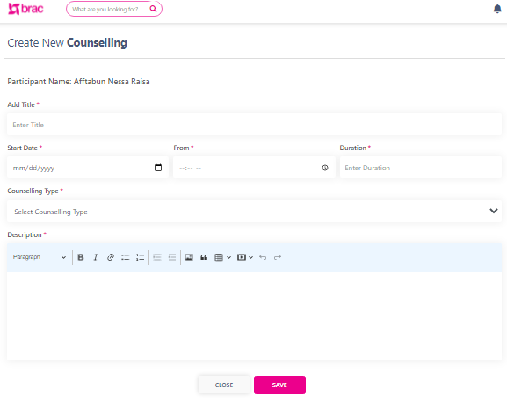

**Click to Create**

**Click to Select**

Figure 24 Create Counselling Form

* This is the counselling Create Form.
* By entering relevant information counsellor create a counselling here.

|  |  |
| --- | --- |
| **Column/Field Name/Icon/Button** | **Description** |
| ***Add Title*** | Enter the relevant title of the counselling |
| ***Start Date*** | Select the relevant start Date |
| ***Duration*** | Duration of the counselling. |
| ***From*** | Relevant time for the counselling |
| ***Counselling Type*** | Select Offline/ Online from the type |
| ***Description*** | Add relevant description for the counselling |
| ***Save*** | Clicking on the button will create counselling session. |
| ***Cancel*** | Click to close the form |

Table 18 Create Counselling Form

* 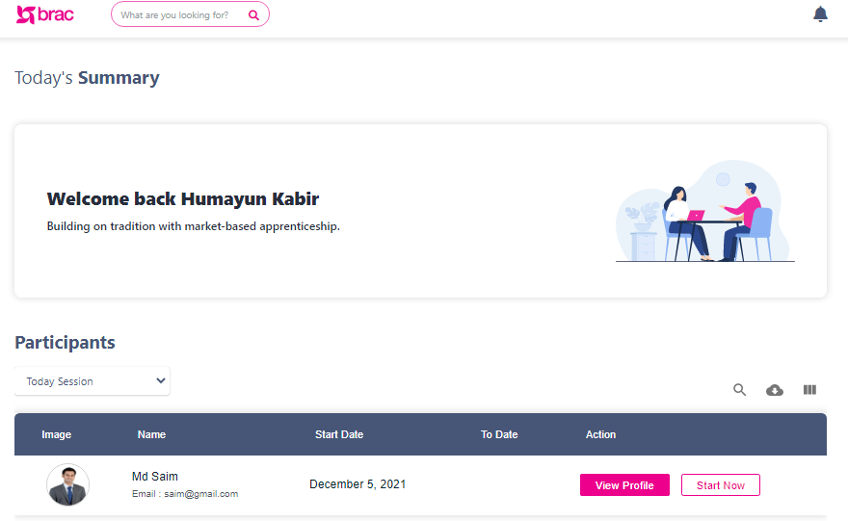After Accepting the Counselling Session by the Participant user counsellor will be able to Start the session

**Click to Access**

**Click to Start**

Figure 25 Counselling Session

* Clicking on the Start Now will Start the Counselling session
* Clicking on the button user will be able to start the online counselling session.

## Create Task for Participant (counselling)

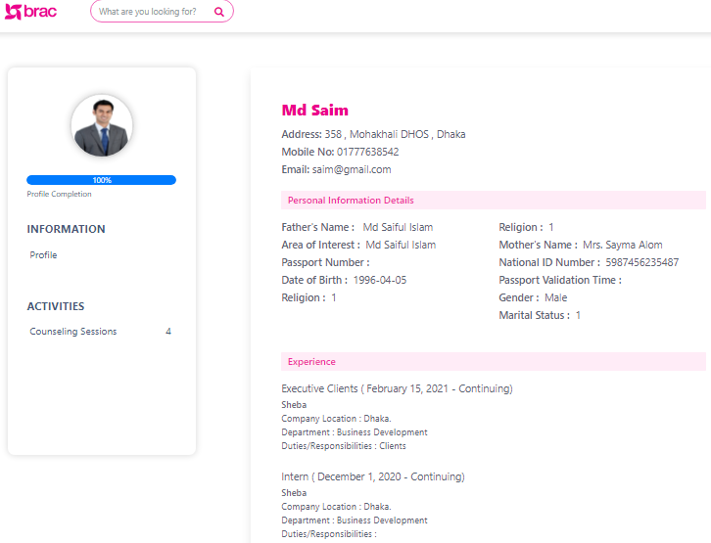

**Click to Access**

Figure 26 Participant Profile page

* Clicking on the button user will be able to create task for participant in the counselling.

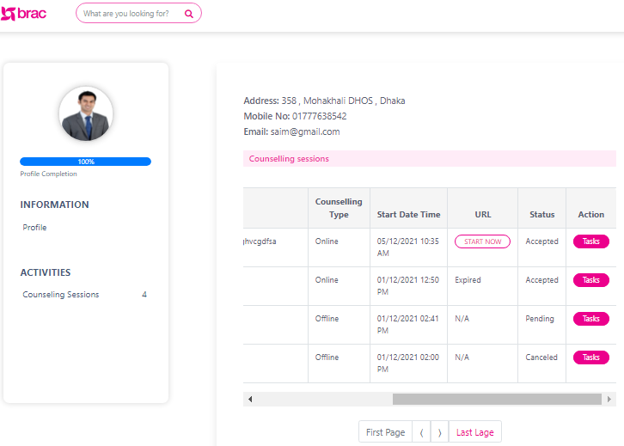

**Click to Create Task**

Figure 27 Counselling Session Page details

**Click to Start**

* User can start a session from here;
* User can assign a task to participant from here;

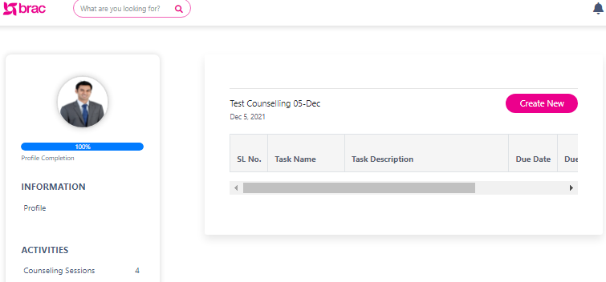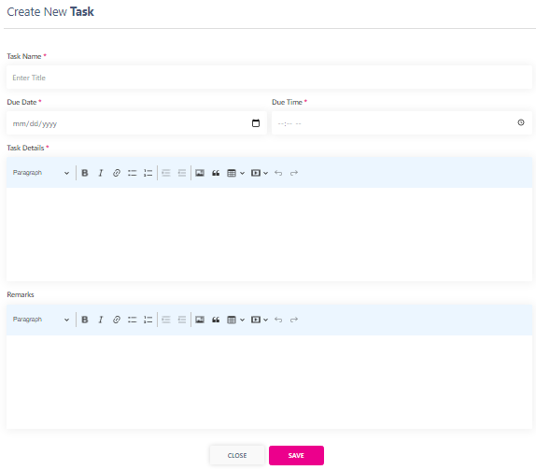

Figure 28 Create New Task Form

**Click to Start**

Figure 29 Create New Task (Counselling)

**Click to Create**

Table 19 Create New Task form (counselling)

|  |  |
| --- | --- |
| **Column/Field Name/Icon/Button** | **Description** |
| ***Task Name*** | Enter the relevant name of the task |
| ***Due Date*** | Select the relevant Due Date |
| ***Due Time*** | Due time for the task |
| ***Task Details*** | Add relevant task details. |
| ***Remarks*** | Enter Remarks for the counselling |
| ***Save*** | Clicking on the button will create Task. |
| ***Cancel*** | Click to close the form |

## Already Scheduled Counselling

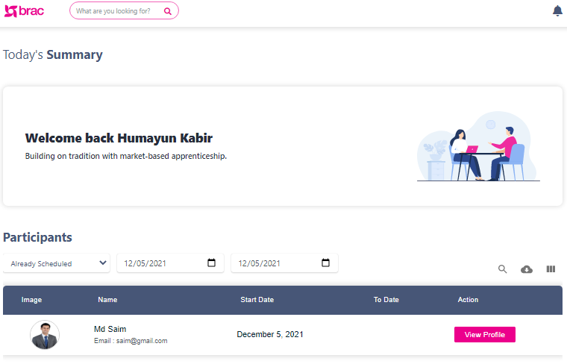

Figure 30 Already Scheduled page

**Click to Select**

**Click to Access**

**Click to Select**

* Here user will find all the scheduled counselling session of the participant.
* User have select Already Scheduled form the drop down.
* User have to select date range from the Date buttons.

# Participant Module

In application’s 4th phase Participant will be able to:

* Access Career Counselling
* Access Request Counselling;
* Access Task In Counselling
* Accept counselling session that are assigned by the user.

Including above, all the other correlated features are dissected and described below.

## Application Registration (Participant)

**Click to Login**

**Click to Registration**

Figure 31 Application landing page

* This is the Application landing page for the external employer;
* Clicking on **Participant** user will redirect to participant registration form.

### Participant Registration Form

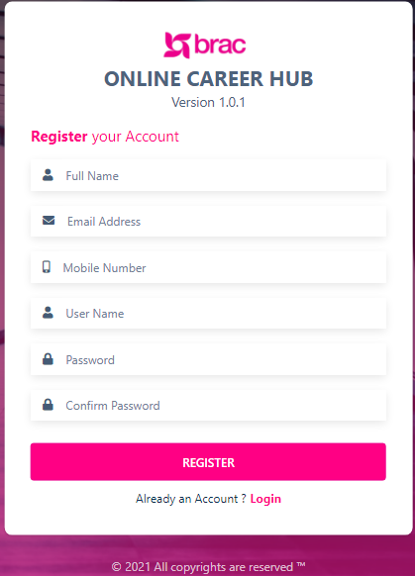

**Click to Register**

Figure 32 Participant Registration Form

* User will enter required information in the form to register.

Table 20 Applications Registration Form Details

|  |  |
| --- | --- |
| ***Field Name/Icon/Button*** | **Description** |
| ***Full Name*** | Enter participant full name |
| ***Email- address*** | Enter relevant mail Address of the participant |
| ***Mobile Number*** | Relevant phone number of the External employer |
| ***User Name*** | Relevant user name of the participant user |
| ***Password / Confirm Password*** | Enter user desired password , again confirm the password |
|  | Click to confirm registration. |

### Participant Login

**Click to Login**

Figure 33 Login Form

* Enter User Name and Password
* Click to Login

### Participant Dashboard

**Click to Access**

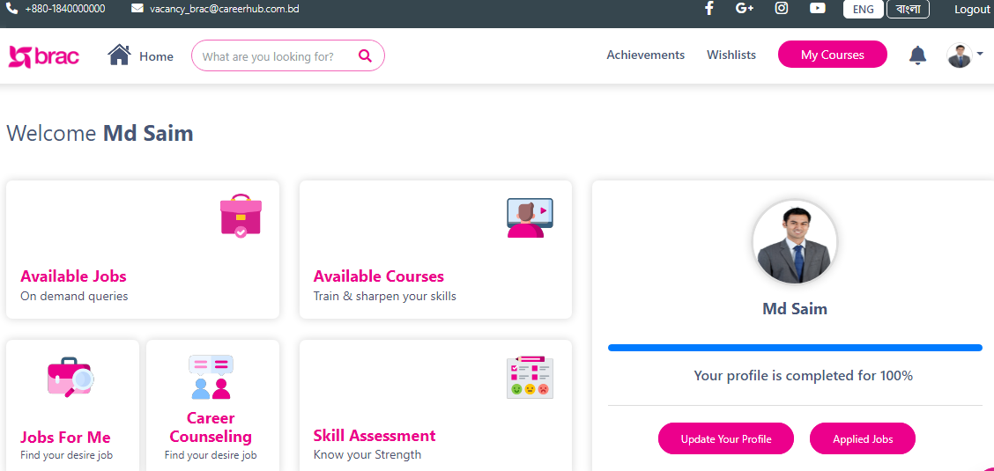

Figure 34 Participant Dashboard

Figure 35 External Employer Dashboard

* This is the dashboard of an Participant user;
* User will find **Career Counselling**.
* Clicking on Career Counselling user will redirect to Career counselling list page.

## Career Counselling list

**Click to Access**

**Click to Request**

Figure 36 Counseling List

* Here participant can Request for a counselling session
* Participant cam complete as task from here.

Table 21 Counselling List Page details

|  |  |
| --- | --- |
| **Column/Field Name/Icon/Button** | **Description** |
| ***Counselling Title*** | Enter the relevant title of the counselling |
| ***Start Date /Time*** | The relevant start Date and time |
| ***Duration*** | Duration of the counselling. |
| ***Status*** | Status of the counselling. |
| ***Counselling Type*** | Offline/ Online counselling type |
| ***Description*** | Relevant description for the counselling |
| ***Action*** | Relevant action for the counselling. |

### Task List (Counselling)

**Click to Request**

Figure 37 Task List Page

* Here user will find all the task that are assigned to a participant.
* User will find this under the **Career Counselling** menu at the **Counselling list tabl**e in **Action** column.

### Request Counselling

Figure 38 Request Counselling Form

* From here user can request for a counselling session.

Table 22 Request Counselling form details

|  |  |
| --- | --- |
| ***Field Name/Icon/Button*** | **Description** |
| ***Select Center*** | Select Relevant Center Form the drop down |
| ***Start Date*** | Select relevant start date. |
| ***To Date*** | Select To date |
| ***Save*** | Clicking on the button will create a counselling request |
| ***Close*** | Clicking on the button will close the form |

* 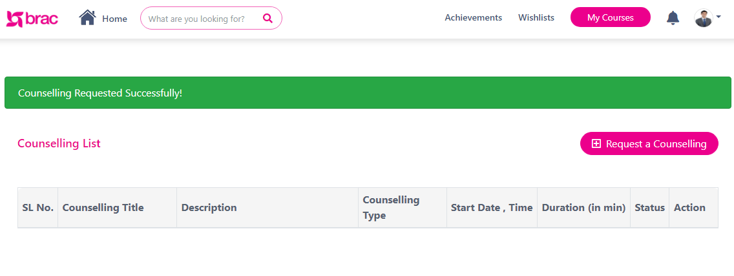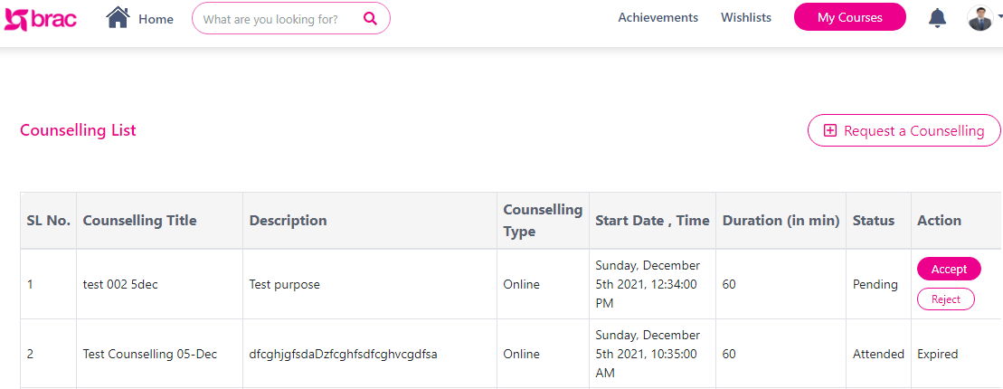After requesting a counselling session, the counsellor will create a Counselling Session.

**Confirmation Message**

Figure 39 Counselling Lists Table

Figure 40 Confirmation message for Request counselling session

**Click to Accept or Reject**

* 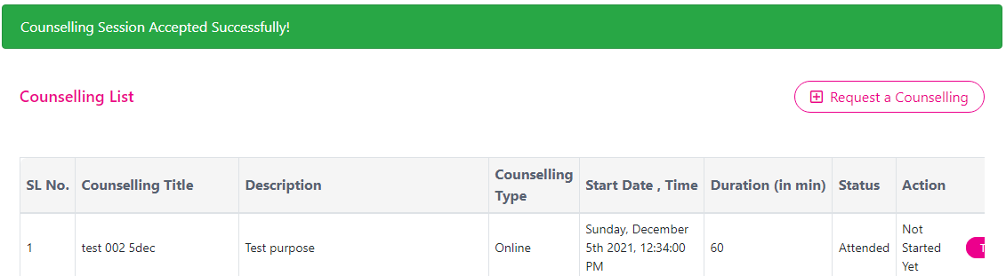Participant will have to accept the Session that have been created by the Counsellor.

Figure 41 Confirmation Message

* After Accepting user will get this confirmation message

### Join A Counselling Session

Figure 42 join a session

**Click to Join**

* From here participant will be able to join a counselling session
* Clicking on the Join Now button user will be able to join a counselling session.

Table 23 Counselling list Table details

|  |  |
| --- | --- |
| **Column/Field Name/Icon/Button** | **Description** |
| ***Counselling Title*** | Enter the relevant title of the counselling |
| ***Start Date /Time*** | The relevant start Date and time |
| ***Duration*** | Duration of the counselling. |
| ***Status*** | Status of the counselling. |
| ***Counselling Type*** | Offline/ Online counselling type |
| ***Description*** | Relevant description for the counselling |
| ***Action*** | Relevant action for the counselling. |

\

## Join Seminar

* 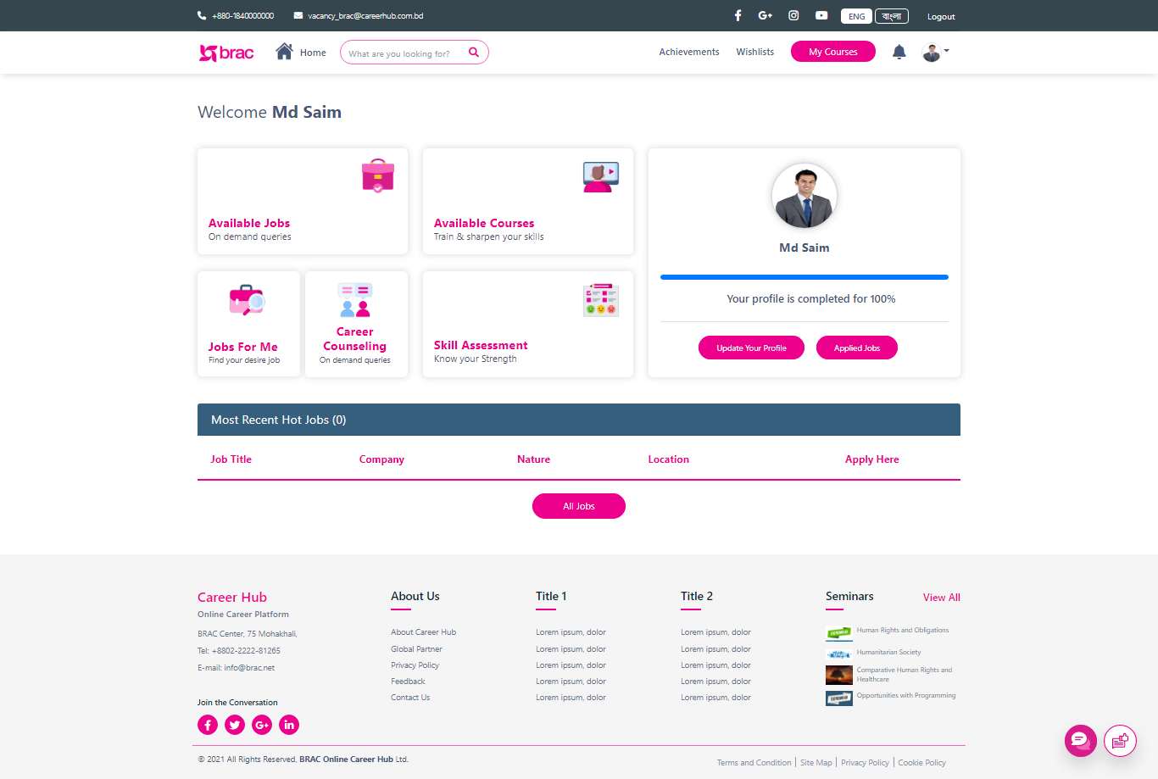Form the bottom of the dash board participant will find the details about the Web Seminar

**Click to Access**

**Click to Access**

Figure 43 Participant Dashboard (Seminar)

* Here user will find all the seminar details.
* Clicking on the View All button user will be able to access all the Web Seminar

### Seminar Page

Figure 44 Seminar Page

**Click to Access**

* Clicking on the view card user will redirect to that relevant Seminar page.

## Chat Bot

**Click to access Portal Feedback**

**Click to enter text**

**Click to send text**

Figure 45 Chat bot

* From here user can send text and can get information from the chat bot.
* From here user can Access Portal Feed ;

## Portal Feedback (Participant)

**Click to Select**

**Click to Enter**

**Click to Enter**

**Click to Select**

Figure 46 My Portal Feedback page

* 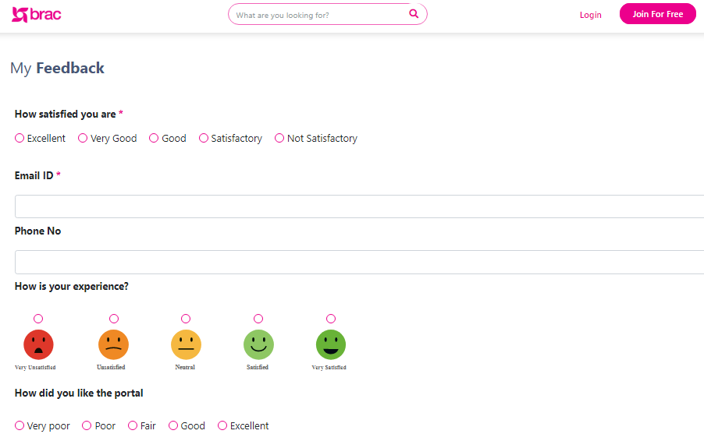From here participant can give portal feedback.
* By selecting relevant field/ options user can give a feedback and the response will show to the admin panel